

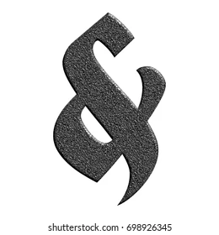


The Island Casino
March 13th-14th
$159 per person double occupancy.
Depart GV Park and Ride at 12pm.
Trip includes transportation, ticket to the show, and hotel room. Also receive a $5 breakfast coupon and $20 promo cash.
Return home at 3:30pm

