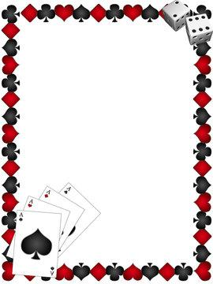

Potawatomi Carter Casino Day Trip
January 17th
A 4 hour stay at the Potawatomi Casino in Carter, includes $10 in promo cash.
Only $10 per person.
Depart Little Chute Park and Ride at 8:30am. Depart GV Park and Ride at 9:00am.

