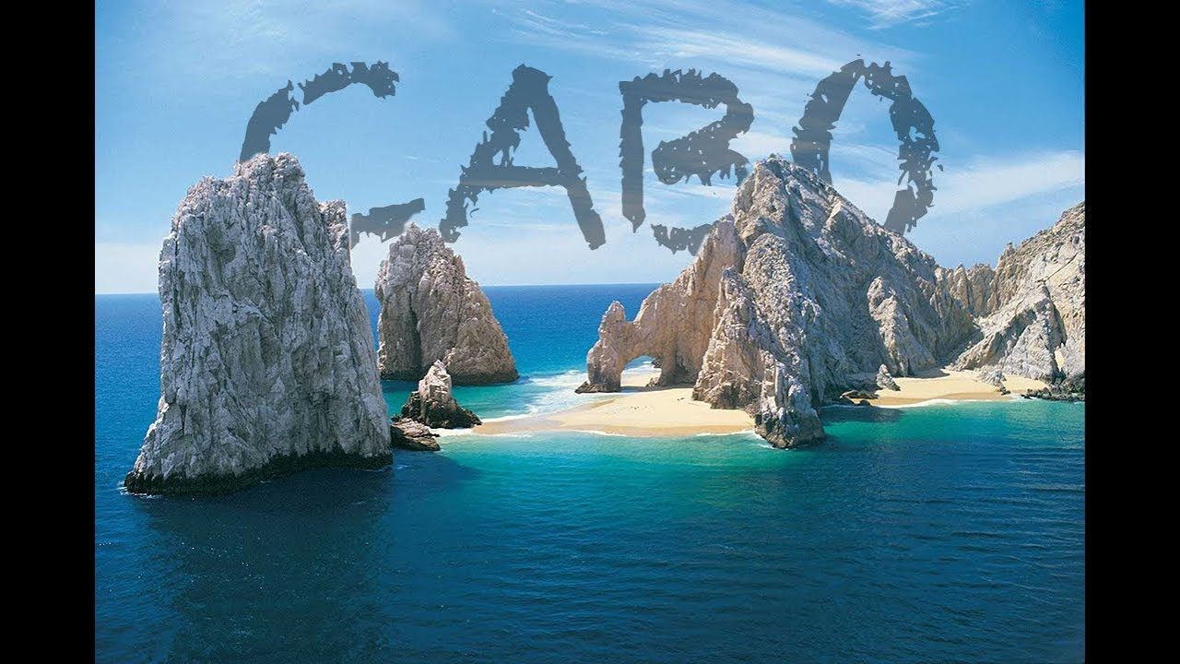  BARLEY’S PUB  - CABO SAN LUCAS  OCTOBER 25-NOVEMBER 1, 2025  $2,075.00 PER PERSON (DOUBLE OCCUPANCY)  $3,100.00 SINGLE RATE  $250.00 DEPOSIT PER PERSON AT TIME OF SIGN UP  $400.00 PER PERSON DUE APRIL 1  $400.00 PER PERSON DUE ON JUNE 1  $400.00 PER PERSON DUE ON AUGUST 1  BALANCE DUE ON SEPTEMBER 1  CHECK OR CASH ACCEPTED, CREDIT CARD INCURS A 3% CHARGE  TRIP INSURANCE IS AVAILABLE AT THE RATE OF 7.2% OF THE COST OF THE TRIP  NO REFUNDS AFTER AUGUST 1 WITHOUT TRIP INSURANCE  FOR MORE INFORMATION OR TO SIGN UP PLEASE CALL  BARLEY 680-3977 OR DIANE 468-7738 | TRIP INCLUDES:  ROUND TRIP AIRFARE FROM CHICAGO  BUS TRANSFERS IN US AND MEXICO  ALL INCLUSIVE @TESOROS RESORT (SOME RESTRICTIONS APPLY)  OPTIONAL SIDE TRIPS FOR  GOLF  FISHING  ROOF TOP PARTY  CATAMARAN  DINNER BOAT

