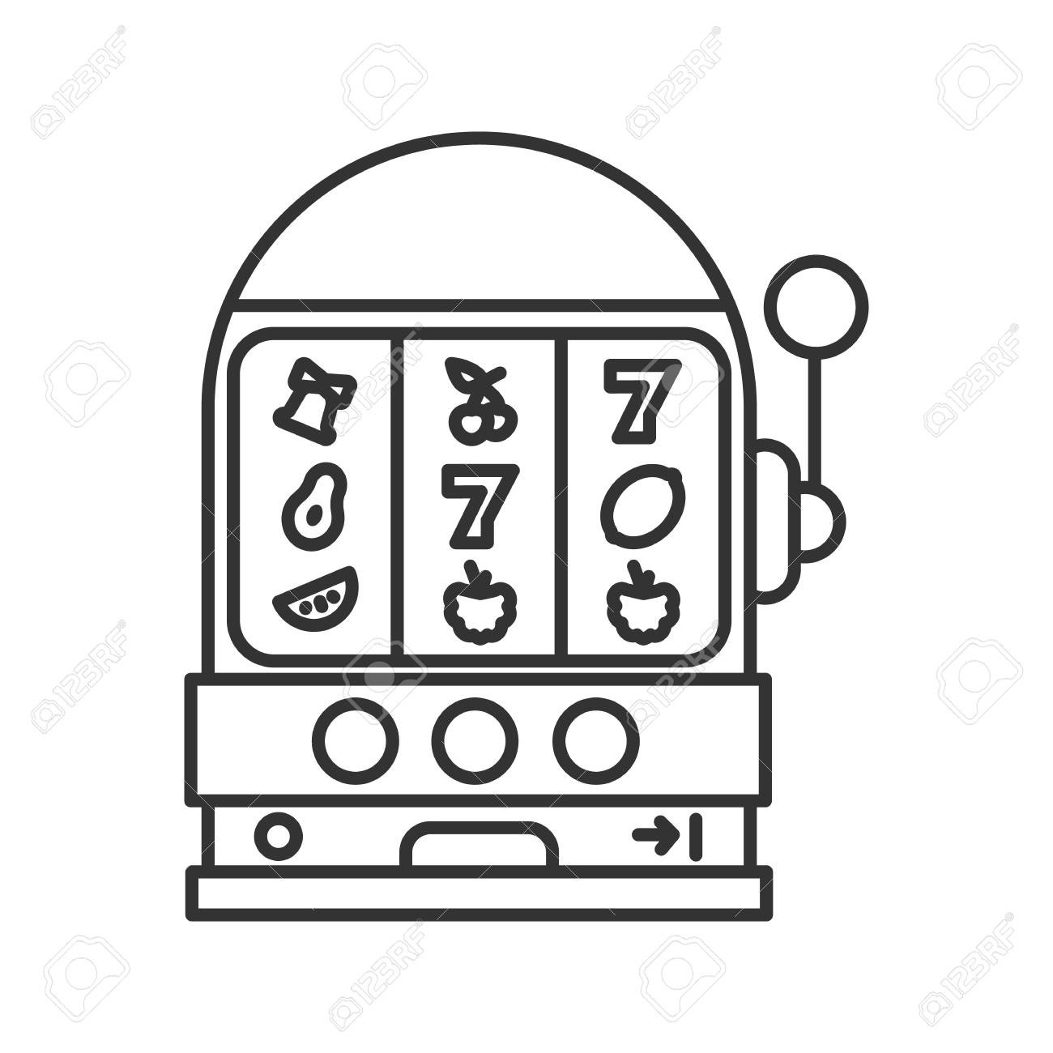

Legendary Waters Casino Trip

April 27th - 29th

$179 per person double occupancy

April 27th: Depart Little Chute Park and Ride at 6:30AM, GV Park and Ride at 7AM, 8AM Arrival at Ho Chunk Gaming in Wittenberg, lunch on your own at the casino with $15 promo cash, 12PM departure from Ho Chunk, 2PM rest stop at Kwik Trip in Minocqua, 4:30PM- 5PM estimated arrival at Legendary Waters Resort and Casino with dinner on your own and $25 Promo cash.

April 28th: Breakfast at the casino, Depart Legendary Waters at 9AM for Bad River Lodge and Casino, 4 hour stay includes spin the wheel and $20 promo cash, dinner on your own back at Legendary Waters including another $25 promo cash.

April 29th: Breakfast at the hotel, last morning includes $25 promo cash plus with every 50 points earned on your players card gets you a rip ticket with a chance to win up to $25 more promo cash (limit 4 per player), Depart for home at 11AM, lunch/ rest stop at Culvers en route.

Sign up form
Name:

Phone Number:

Address:

Email:

Birthday:

Pick up site:

Name:

Phone Number:

Address:

Email:

Birthday:

Pick up site:

