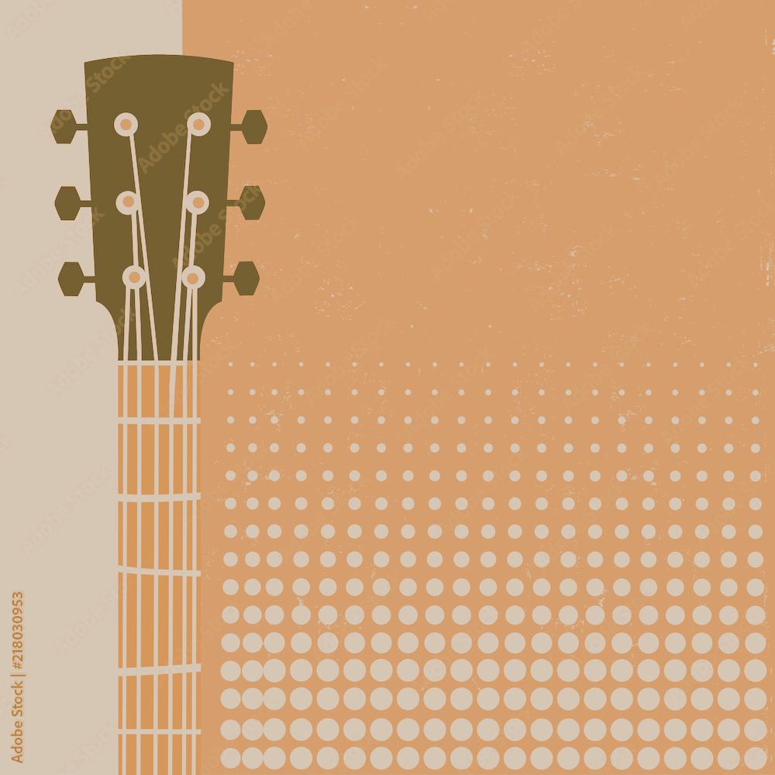
KANSAS
AT THE ISLAND CASINO
FEBRUARY 27TH & 28TH $159 PER PERSON DOUBLE OCCUPANCY, $225 SINGLE. DEPARTING GV PARK AND RIDE AT 12PM. RETURNING HOME AT 3:30PM. SEATS AT THE SHOW ARE CENTER STAGE, ROWS 16-18
THIS TRIP INCLUDES YOUR CONCERT TICKET, TRANSPORTATION, HOTEL ROOM, $40 PROMO CASH, AND A $5 BREAKFAST COUPON.

SIGN UP
NAME:

ADDRESS:

BIRTHDAY:

ISLAND CARD NUMBER:

NAME:

ADDRESS:

BIRTHDAY:

ISLAND CARD NUMBER:

